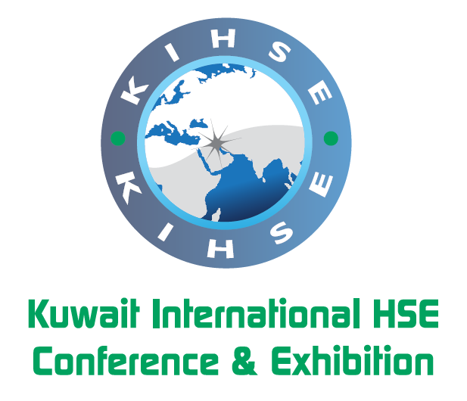
For Immediate circulation

Kuwait’s KIHSE-2015 conference and exhibition draws a growing interest regionally and internationally
Kuwait City – January 20, 2015. With over 70 confirmed speakers and a growing number of sponsors, exhibitors and delegates, the “Kuwait International HSE conference and exhibition” (KIHSE-2015) has consolidated its position as a leading world-class regional event in Kuwait.
Held under the high patronage of HE Dr. Ali Saleh Al-Omair, Kuwait’s Minister of Oil and Minister of State for National Assembly Affairs; and hosted by the Kuwait Petroleum Corporation (KPC), KIHSE-2015 aims to promote Kuwait’s commitment to the highest standards of health, safety, and environmental (HSE) practices.
It is expected to become a major drive for HSE awareness, not only in the petroleum sector, but also across all economic and social activities in the country, creating a culture of commitment to a healthy, safe and environment-friendly society.
The KIHSE-2015 will take place on 16 and 17 February 2015 in the Regency Hotel and Conference Centre in Kuwait City and will run around the main theme of, “We Can Make a Difference to Our World.”
In addition to the full support and endorsement by the KPC and its subsidiaries, this world-class event has attracted a big interest from the oil and gas industry in Kuwait and the GCC region, as well as other parts of the world.
This interest has been reflected in the important contributions from business leaders, experts and decision makers who joined the KPC and its subsidiaries in recognizing the importance of HSE as a key issue for the whole energy sector. The KIHSE programme has gathered over 70 speakers, including:

HE Dr. Ali Saleh Al-Omair, Minister of Oil and Minister of State for National Assembly Affairs

HE Mr. Abbas A. Al-Naqi, Secretary General, Organization of Arab Petroleum Exporting Countries (OAPEC)

Mr. Nizar M. Al-Adsani, Deputy Chairman & Chief Executive Officer, Kuwait Petroleum Corporation

Mr Ali Al‐Jarwan, Chief Executive Officer, Abu Dhabi Marine Operating Company, ADMA‐OPCO

Mr. Mohammad Husain, President and CEO, EQUATE Petrochemical Company

Mr. Hashem Sayed Hashem, Chief Executive Officer, Kuwait Oil Company

Mr. Mohammad Al-Mutairi, Chief Executive Officer, Kuwait National Petroleum Company

Mr. Asaad Al-Saad, Chief Executive Officer, Petrochemicals Industries Company

Mr. Peter Bartlett, Chief Executive, Bapco

Dr. Mohammed Yousef Al-Mulla, Vice Chairman & CEO, QAPCO

Mr. Raoul Restucci, Managing Director, Petroleum Development Oman (PDO)

In addition to a long list of other managers, experts, and consultants in the HSE fields. The packed programme will also include 30 poster-presentations by local and international HSE experts during the accompanying exhibition.

Additionally, a growing number national and regional sponsors and exhibitors have aligned themselves with the event, including some of the most important state companies and leading oil and gas players in the region like Chevron, Petrofac, Technip, and many others.
The adjacent specialized exhibition will permit more than 50 companies to showcase the latest in HSE technologies and services. This exhibition will boast national, regional and international companies, providing them with the opportunity to present their latest products and services.
This web of activities ensures that participants will have access to all the latest information and technologies to guarantee that HSE best practise solutions and methods are available to more than 500 attending delegates and business leaders.
Strong topics
The Conference programme includes 3 themed tracks for Health, Safety and Environment; along with a set of plenary sessions, to provide an in depth coverage of the key topics related to the development of a sustainable HSE culture.

The plenary sessions will focus on the HSE management practices and strategies in general and will provide a platform to discuss strategic topics, including a view by major regional CEOs on the importance of HSE matters.

Each one of the three other tracks will provide a set of sessions with highly strategic topics presented by major international experts in the HSE field.

The organizers of the event expected KIHSE-2015 to become a platform for involved oil companies, their prospective suppliers and members of the civil society to meet and network, benefiting from Kuwait’s remarkable advancements in the HSE fields.
Petrochemicals Industries Company (PIC), a subsidiary of KPC, is among the main supporters of KIHSE-2015, which reflects the company's commitment to HSE practices. In this context, PIC’s Chief Executive Officer, Asaad Al-Saad, indicated that the company allocated 17 percent of the total value of its projects to HSE-related projects. He added that PIC gives priority to HSE training to boost the performance of its workforce and to reduce the number of industrial accidents.

Al-Saad explained that HSE training courses represented 60 percent of all training courses for employees at PIC. He added that 85 percent of PIC staff participated in HSE training, and that more than 85 percent of enrolled employees successfully passed these training courses.
In addition to business activities, the KIHSE conference, will be conducting several activities that aim to inform and educate the industry about the advantages of having proactive and forward-leaning HSE Policies and effective management systems, according to KPC sources.
KIHSE is an initiative by KPC, and is organised in collaboration with Global Events Partners Ltd (GEP), a major UK-based event management company affiliated to the dmg::events network.
*****(ENDS)******
To learn more about the event, how to participate and other details on the programme, participating delegates, speakers and sponsors, please visit: www.kihse.com .
***********
To confirm Interviews and appointments please Contact:
Gail Williams, on gwiliiams@gep-events.com or tel: +44 1737 784953 or Nawal on 5088 6202

